Callide Valley Agricultural & Pastoral Society Inc.

PO Box 461, Biloela, Qld 4715

49922688

cvapbilo@bigpond.com

www.callidevalleyshow.com

TRADE SITE AGREEMENT
19TH & 20TH MAY 2023
Conditions, Rules and Regulations agreed to by the Site Exhibitor

Please read carefully and return with signed Site Agreement with payment.

- Approved Goods: When applications are made for sites the nature of goods wishing to be sold must be detailed and must not be changed after approval has been given. This applies particularly to foodstuffs and drinks as some lines are restricted to Showmen’s Guild and others are approved lines to local Service clubs and the Auxiliary Committee of the C.V.A.&P. Society Inc.
- Displays: All sites booked must be claimed by 5pm Thursday 5th May 2023 or will be given to the next in line (unless prior arrangements are made). All displays must be completed by 7pm Thursday 18th May 2023. Setting up of displays may be commenced anytime from the weekend prior to the Show, after advising Secretary of intention. Pavilions will close 6pm Wednesday and 7pm Thursday nights and reopen 8am Friday morning for site-holders to finalise display in readiness for public opening at 8.30am. Pavilions will be closed to the public on Friday night at 7pm and will reopen at 8.30am Saturday (unless otherwise requested)
- Dismantling of Goods: All goods or displays must not be dismantled or removed before 5pm Saturday without the approval of the Society Chief Steward. Pavilion displays must be removed within 14 days or additional ground rental will be charged. All areas must be left clean. This applies to the removal of star pickets defining areas, buntings and any items not belonging to the Show Society.
- Allocation of Sites: The organisers reserve the right to re-allocate space in the interest of a better showing of exhibits. Sites are available in multiples of 3 metres. Camping/Staying on ground is at a cost of $25 including GST for Friday and Saturday night of Show and is to be paid with site fee.
- Gambling: Disposal of articles by lot or chance, and the sale of Art Union tickets is strictly prohibited.
- Offensive Material: The Chief Pavilion or Ground Steward shall have the power to enter the rented site described and remove any article, sign, picture or printed matter which in his/her opinion may be a cause of offence to the public or the Society.
- Hawking: The Site Exhibitor must confine their business to the purpose described. No selling, hawking, or distribution of printed matter will be permitted outside the rented space.
- Advertising: The display of approved advertising is restricted to the Site occupied by the Exhibitor.
- Cancellation: No cancellation may be considered unless the site-holder applies for such release from his obligation in writing to be received by the Secretary seven days prior to the commencement of the Show. No part of area may be sublet without approval of the Chief Steward of the area or the Secretary.
- Trade Vehicles: Vehicles conveying supplies and vehicles owned or used by Site-holders are not permitted to remain for more than 15minutes of Friday or Saturday Show Days. They must be removed and parked in the designated paring area by 8.30am each day. Each vehicle must carry a site-holders parking sticker which is available from the Secretary’s office prior to the Show.
- Wastewater: All wastewater on site is to be dispersed into containers and not onto the ground. Containers are to be emptied at an appropriate point as directed by Chief Steward or Secretary.
- Excavation: Under no circumstances shall a site holder excavate, dig or place pegs on the Site without first obtaining the consent of the Chief Ground Steward, Secretary or Showground Trustees. The Site holder shall be liable to the Trustees for any damages or loss suffered by the Trustees and indemnifies the Trustees in respect to death or injury to any person occasioned by such action.
- Free standing Displays: Free standing displays in the Pavilion must be secured, but not attached to walls or floors by fasteners.
- Microphones: sound amplifiers and machine demonstrations will be permitted where the level of sound causes no annoyance to neighbouring site holders or visiting public. The Society shall be the sole judge as to whether there is any annoyance to the other site holders or the visiting public.
- Water Usage: Water usage must be controlled. No overnight, unattended sprinklers allowed in the preparation of industrial sites. No washing down of vehicles or displays is permitted. Water usage must be controlled in accordance with Councils water restrictions.
- Fire Fighting Equipment and Electrical Switchboards: No Site-holder shall obstruct the use of any fire fighting equipment or electrical switchboards. Free access must always be maintained to the above equipment. Site holders are required to carry at least one fire extinguisher of approved type and be suitable for use on the display.
- Damage: The Society accepts no liability for damages to Site holders exhibits by loss, damage, theft, fire, water, storms, strikes, riots or any other cause whatsoever. All precautions are taken. A security firm is engaged overnight during the Show to patrol the grounds.
- Power: The Society reserves the right to restrict the amount of power used by any Site-holder, and to charge for excessive power consumption. The charge may be in two parts – energy and head work.
- Liability Insurance: The Society shall not be responsible for any damages claimed by any person or persons, who may be injured whilst in the Site allocated to the Site holder and the Site holder agrees to indemnify the Society in the event of any claim made against the Site holder. Site holders are required to produce a current Public Liability Insurance Policy.
- All Pavilion Sites: Fee for inside sites are to be paid in full fourteen days prior to the commencement of the Show to ensure site is held. Outside Site holders are required to pay a deposit at time of booking; at least half of the total anticipated cost of the site fourteen days prior to the commencement of the Show. The remainder of site fees are to be paid at the Secretary’s office prior to taking up the Site.
- Electrical Appliances: Site holders are to ensure that ALL power leads and electrical appliances display a current tag indicating that each lead has been tested and approved by an authorised person in accordance with the requirements of the Workplace Health and Safety Act, i.e. that the lead has been tested after 1 January 2023.
- Banned Items: Site holders please note on page 3 (list of Banned Items at Agricultural Shows in Queensland). If you require visuals, please contact the Show office and they can be sent to you.
- Animals: Site Holders are not permitted to have animals (i.e. dogs, cats or other pets) on the show grounds subject to the Banana Shire Council by-laws except in the instance that the animals are for the sole purpose of conducting business i.e. Camel ride or Animal Nursery and will be at the discretion of the Society.
- COVID: Site holders must adhere to all current government directives and regulations regarding their own business standards and those of the Society in relation to COVID at the time of the Show, i.e. Safety checklist, mask usage, vaccination status. If the Annual Show is cancelled due to COVID, a refund less the administration fee will be applicable.

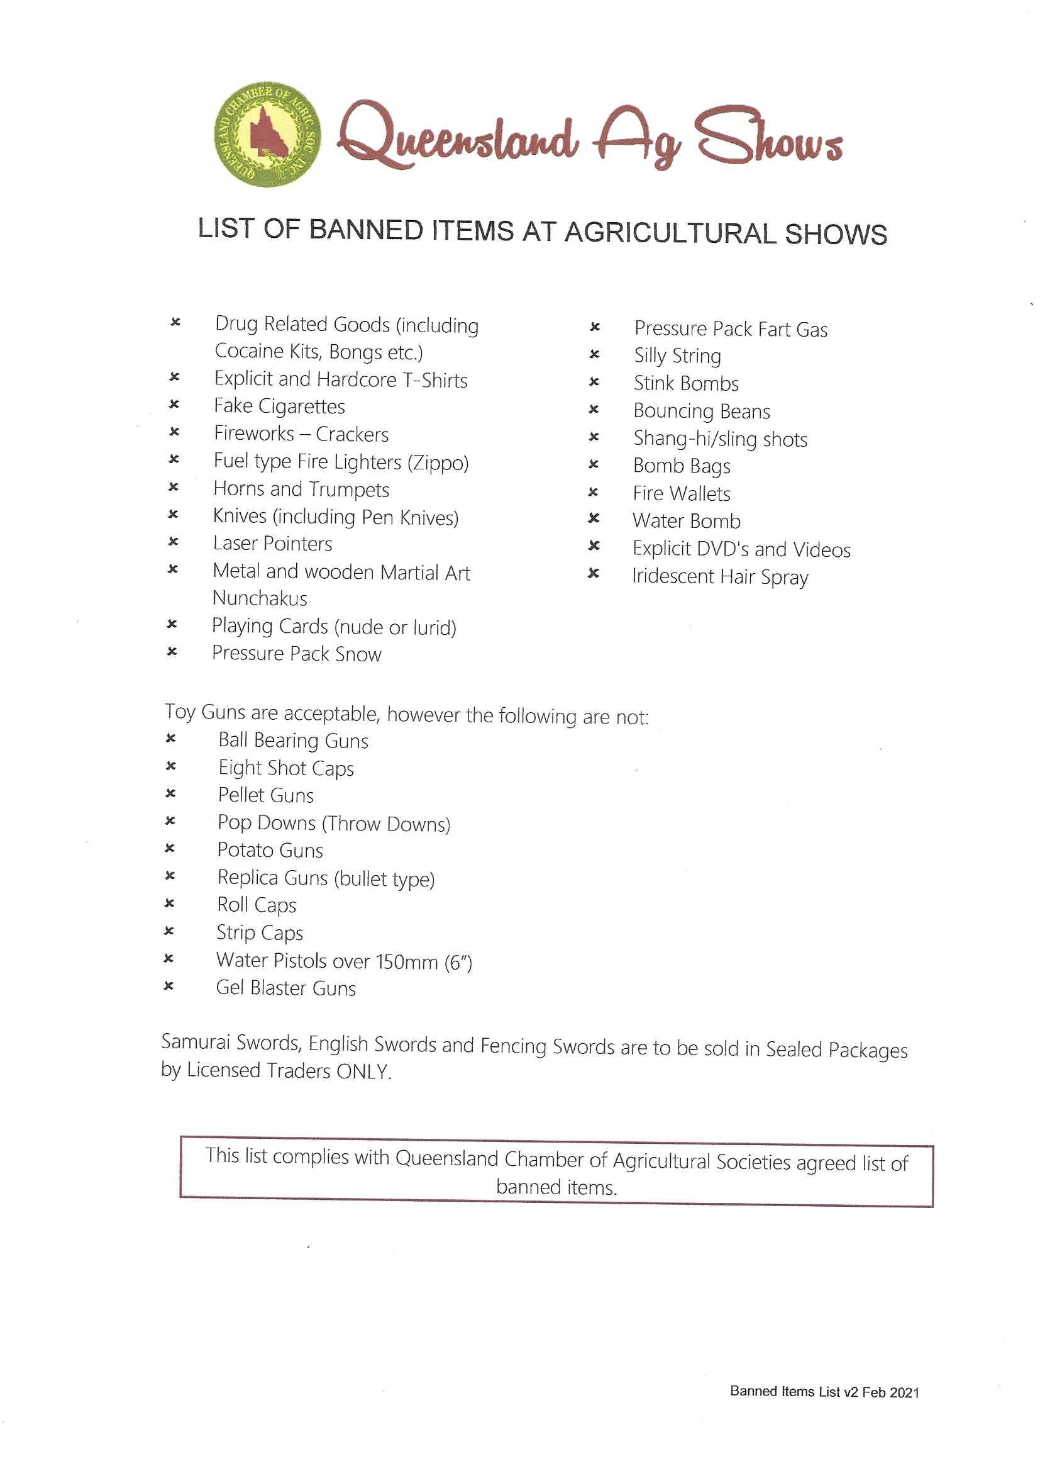

Please complete this Site Agreement and return together with your Site Fees (Refer to Condition 20).
CONTACT DETAILS:
Ste-holder’s Name: |  |  | ABN:
Address:
Email: |  |  | P/Code:
Contact No.’s: | Business: |  | Mobile:
 | Home: |  | Fax:

NATURE OF GOODS TO BE SOLD/DISPLAYED:
Please list the nature of goods to be displayed/sold (Refer to Condition 1):

SPACE REQUIRED:
 |  | Inside/Pavilion Sites  Most inside sites/pavilion sites measure 3m x 3m. Some are 3 m frontage by 1.2 m depth  I/We require an Inside/Pavilion Site @ $11 GST inc per sq. metre, measuring : |  |  |  |  |  | ….m Frontage  …... m Depth |  | Total  Sq. Metres  ….. sq m²
Outside Sites:-
NOTE: We have FOUR DEPTH SIZES available of 3m, 6m, 9m and larger sizes for machinery , cars etc.
. Please tick the site size you require below.
A |  | 3m deep @ $17.80 per metre frontage  (No camping on site unless in display unit. Camping fee applicable at $25.00 for duration of the show)
B |  | 6m deep @ $21.00 per metre frontage
C |  | 9m deep @ $19.40 per metre frontage
D |  | Over 9m deep @ $18.60 per metre frontage
ALL APPLICANTS PLEASE NOTE: You are to ensure that the dimensions provided cover stays & pegs on tents and length overall is to include drawbar and trailers/caravans etc so as not to infringe on adjacent sites.
FURTHER NOTE Those wishing to have their accommodation in areas B, C, D, be it tent/camper Van/Pan Tec/ Lockable Trailer/ Caravan or Mobile Home at the back of their sites, are to ensure they are in position early as a courtesy so that adjacent site holders can prepare their sites in readiness for the Show
SIZE OF SITE REQUIRED:
Total Frontage: |  |  |  | Depth:
Please use increments of three (3) metres.
POWER REQUIREMENTS:
 | I/We require single phase power. (Refer to Condition 18). |  |  |  |  |  |  |  | Amps.
 | I/We require three phase power. (Refer to Condition 18). |  |  |  |  |  |  |  | Amps per phase.
 | OR |  |  |  |  |  |  |  | Hp or KW Capacity of motor.

PUBLIC LIABILITY INSURANCE:
Please provide a copy of certificate of currency in accordance with Condition 19 attached.
CALCULATIONS:
Please note that 2 day free passes will be allocated accordingly:

Value of Sites Passes Allocated
$0.00 - 150.00 2 Passes
$151.00 $250.00 3 Passes
$251.00 - $500.00 4 Passes
$501.00 - $950.00 5 Passes
$951.00 - $2250.00 6 Passes
Inside/Pavilion Site - ……. of sq. metres @ $11 per sq. metre:
Outside Site Option
A | …...m frontage @ $17.80 per m
B | ……m frontage @ $21.00 per m
C | …...m frontage @$19.40 per m.
D | ……m frontage @ $18.60 per m
Administration fee: |  | $8.50 | $8.50
Additional 2 day passes: |  | $10.00 each.
Camping: |  | $25.00 inc GST for Friday & Sat Night
 |  | TOTAL SITE FEE:
 |  | DEPOSIT PAID:
 |  | BALANCE OWING:

PLEASE SIGN BELOW:
I have read the Conditions, Rules and Regulations 1 to 24 and hereby agree to comply with the Conditions, Rules and Regulations stated and will advise anyone operating my site of the above Conditions, Rules and Regulations.

___________________________________________ Site-holder’s Signature Date: _______________

Please return your completed Site Application to either PO Box 461, BILOELA QLD 4715 or via e-mail at
cvapbilo@bigpond.com
Banking Details for Direct Debit: BSB 084 548 Account 50862 4383

Prices subject to change!

OFFICE USE ONLY:
Date: |  | Deposit$: |  | Receipt: |  | Invoice: |  | Entered By:

